

Coursework Essay Probing into DeepSeek: Principle Analysis, Application Domains and Optimization Schemes

|  |  |
| --- | --- |
| **First Name** | Yuepeng |
| **Last Name** | Peng |
| **Student CUC ID** | 202229013088N |
| **Student CU ID** | 14564165 |
| **Class** | Class1 |
| **College** | Hainan International college of Coventry University of China (Coventry College, Communication University of China) |
| **Course Teacher** | Qinglan Wei |

# Introduction

Reinforcement learning has long driven breakthroughs in AI. Yet its application in large language models faces persistent challenges: reward hacking, data dependency, and erratic outputs during cold starts. In this essay, we dissect how DeepSeek’s Group Relative Policy Optimization not only overcomes these limitations but also enables LLMs to exhibit human-like reflection, self-correction, and contextual adaptability.

Beyond technical innovation, we envision GRPO-powered LLMs revolutionizing real-world domains like cultural tourism. By integrating local knowledge graphs, visitor behavior analyse, and immersive AR interfaces, DeepSeek could craft personalized travel experiences—transforming static scenic spots into interactive, AI-guided journeys.

Keywords: **Reinforcement Learning, Aha moments, Group Relative Policy Optimization , Cold Start, the local cultural and tourism industry.**

Related work on Github: [KLucen/HW-for-DL: My Coursework for Deep Learning](https://github.com/KLucen/HW-for-DL)

Link to my Cloud Drive: <https://kod.cuc.edu.cn/#s/_o6_XHsg>

# Analysis of core principles

After a cursory review of the papers on the DeepSeek-R1 model and the V3 model, one can't help but marvel at the significant changes made by DeepSeek in the model innovation points. The training process of DeepSeek not only saves the resources required for training (such as: FP8 mixed precision training, Multi-head Latent Attention and DeepSeekMoE) but also has a major breakthrough in the performance of DeepSeek (such as: DeepSeekMoE, Fine-Tuning (SFT) and Reinforcement Learning). However, due to space and content limitations, in this article, I will only focus on **reinforcement learning in DeepSeek**.

When it comes to reinforcement learning, in fact, Google had already applied reinforcement learning to all Atari games as early as 2015, and the fact that AlphaGo defeated the Go champion in 2016 further demonstrated the unlimited potential of reinforcement learning in the field of artificial intelligence.

Now, let's take a look together at what the basic idea of reinforcement learning is exactly like. Here I will explain its working principle in the form of a diagram (Figure 1) : The Agent observes the environment (that is, determines the current state) and then takes specific actions. The actions taken will then affect the environment, thereby giving a reward to the Agent. This cycle repeats itself. The purpose of the Agent is to obtain **the maximum expected reward** after taking actions one after another. If we take Go as an example, the Agent makes a judgment on where to place its next move (action) based on the opponent's moves (observation). Only when the Agent defeats the opponent can it receive a positive reward; otherwise, the reward is negative.

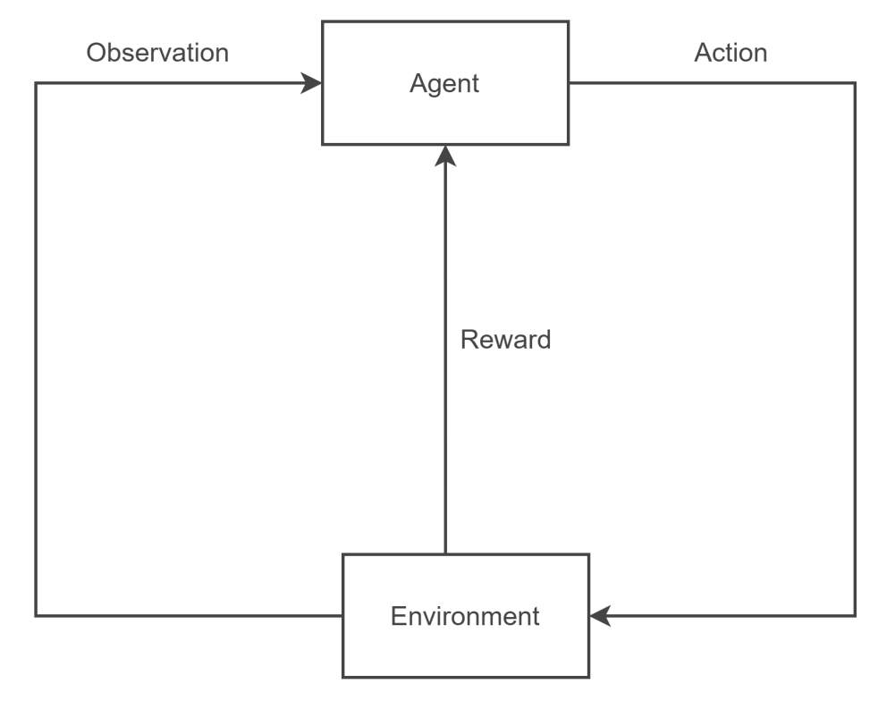

(Figure 1: RL principle)

After understanding the principle of reinforcement learning, we will actually find a problem. If DeepSeek itself is the Agent in reinforcement learning theory, then is the Environment the user's question? I think the user's question belongs to the Environment, but the Environment is not merely the Environment. When we take a close look at the thinking process of DeepSeek in answering our questions and think carefully, we can find that DeepSeek itself is both an Agent and an Environment.

Here is the answer given by DeepSeek when I asked DeepSeek "what is reinforcement learning.":

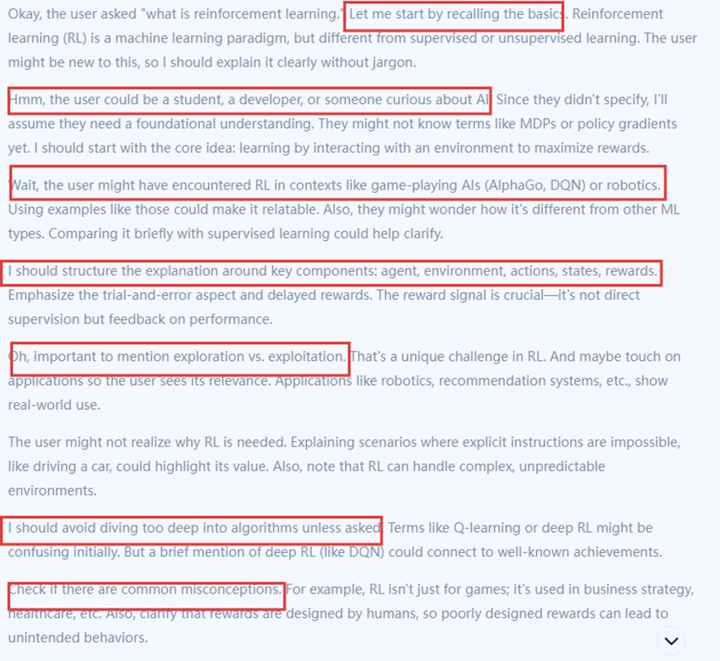

(Figure 2: DeepSeek’s answer 1)

From its thinking process, we can observe that it is not only thinking about the questions we raised, but in fact, it is also reviewing the content it has output itself. (For example, the content I selected in the red box in Figure 2) It first extracted the basic knowledge of RL from the knowledge base in response to my question, then made a conjecture about my identity, and then made guesses about the fields I might be interested in, thereby obtaining the most likely output for it (that is, the output with the greatest expectation of this reward for it).

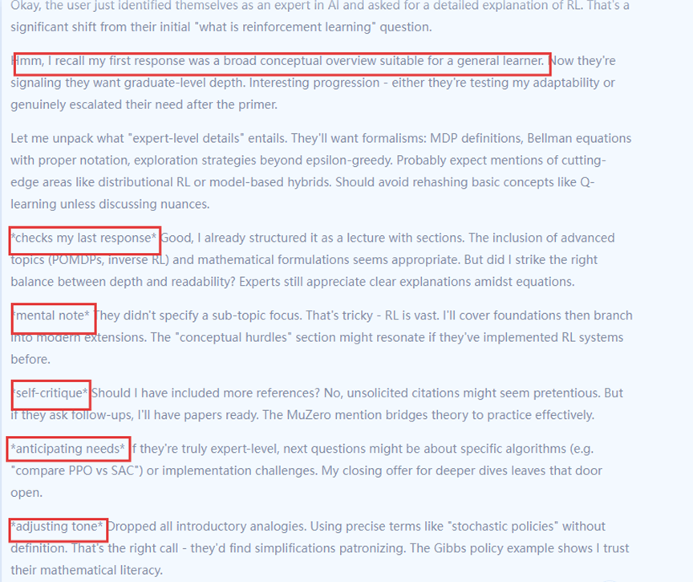

(Figure 3: DeepSeek’s answer 2)

When I told it that I was an expert in the field of AI, it analyzed that I might need more details about RL, reflected on its previous answer, and finally output some technical terms and formulas to me.

Upon conducting a thorough review of R1's paper, it was observed that the designers implemented two primary types of rewards—accuracy rewards and format rewards—to train DeepSeek for reinforcement learning. These reward models can be readily aligned with my recent findings: DeepSeek's analysis of user identity and potential needs is specifically targeted at achieving the maximum accuracy reward. Additionally, the requirement of using **<think></think> and <answer></answer> tags** to separate reasoning content from answers serves as a critical guarantee for maintaining the high quality of DeepSeek's responses.

It is worth noting that when recording the performance of DeepSeek, researchers have discovered the **Aha moments** of DeepSeek. At this point DeepSeek learns to allocate more thinking time to a problem by reevaluating its initial approach. (This also corresponds precisely to the annotations in the boxes in Figures 2 and 3.)

Overall, I have summarized the above content into Figure 4, which summarizes my understanding of how reinforcement learning works in the training process of DeepSeek.

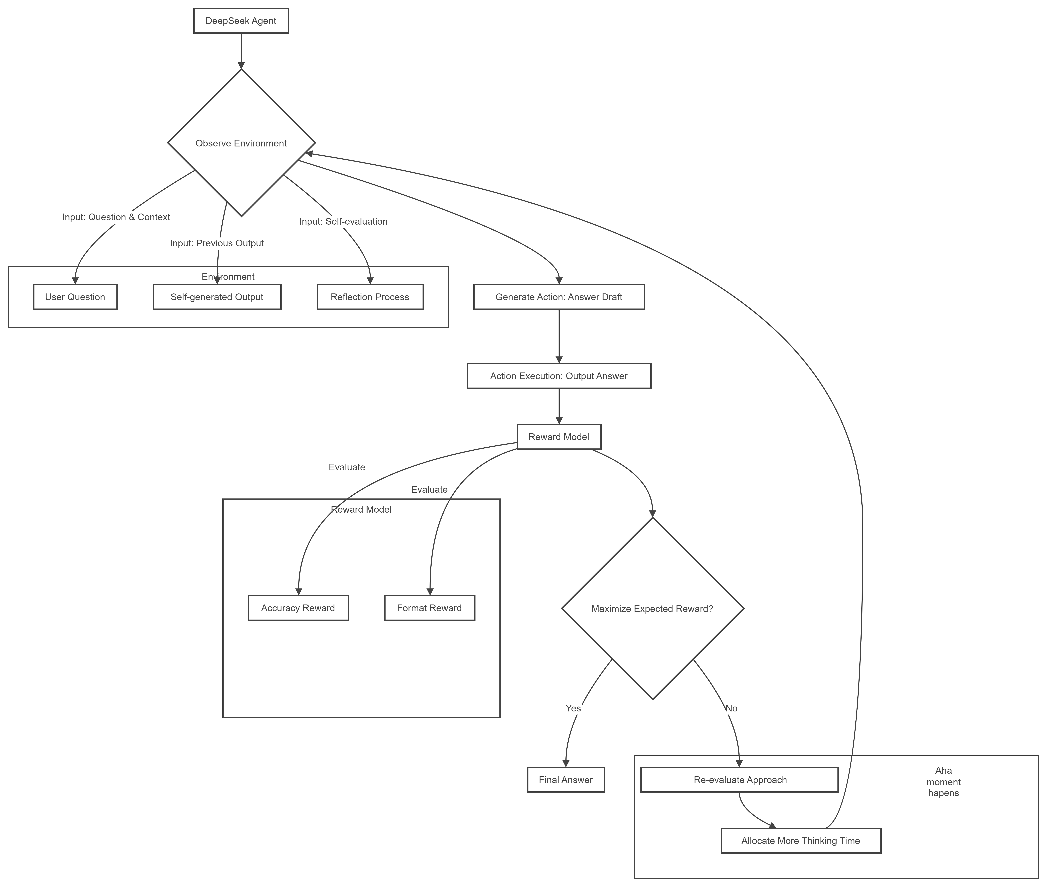

(Figure 4: RL in DeepSeek)

# Technical Optimization Strategies

Overview:

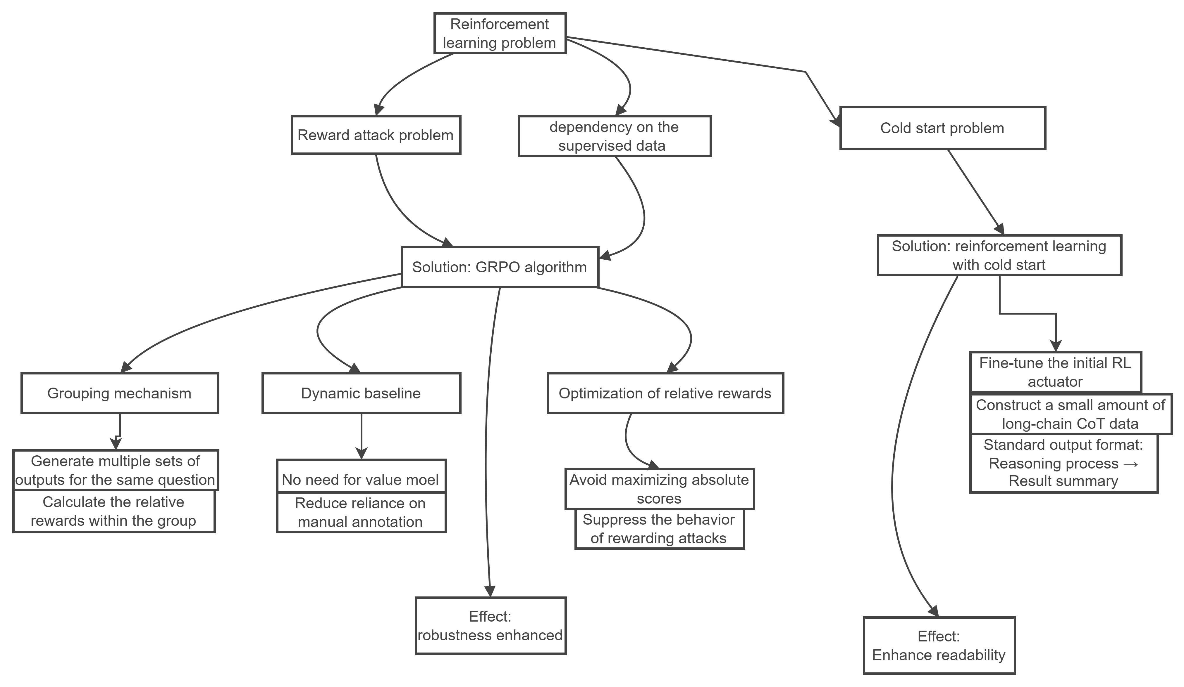

(Figure 5: Conclusion of Optimization Strategies)

Although the incorporation of reinforcement learning has enabled DeepSeek to exhibit complex cognitive behaviors, such as **reflection and re-evaluation**, which are typically associated with human problem-solving processes. However, for a chat-bot, simply using reinforcement learning may expose the model to **reward hacking attacks** (For instance, in pursuit of the maximum reward, they merely mix up related words, but the sentences are not smooth.) and the use of reinforcement learning is highly **dependent on supervised data**.

To address these issues, the designers proposed replacing the traditional **Proximal Policy Optimization (PPO) algorithm with the Group Relative Policy Optimization (GRPO) algorithm**. In the subsequent sections, I will detail the specific aspects in which the GRPO algorithm improves upon the PPO algorithm and explain why it demonstrates superior performance in the training of DeepSeek.

Let's first take a look at the formula of PPO:

This formula represents that we merely optimize our final **absolute score**. The result may naturally lead the model to merely stack related words together to form an incoherent sentence in pursuit of the maximum reward expectation. That is what we mentioned as rewarding hackers.

Now let's take a look at the formula of GRPO:

where

calculates a “**relative score**” by averaging multiple outputs from the same question and normalizing.

Whether it is from the names of GRPO and PPO or their respective formulas, it becomes evident that GRPO builds upon PPO by introducing the concept of groups. Specifically, GRPO realizes that for the same task, the model will provide multiple different outputs. Then, based on the average score of the outputs, the outputs with relative advantages are screened out. Finally, the strategy is updated based on the decisions made from the advantageous outputs, thereby maximizing the objective function of GRPO. In this way, the reward model is continuously trained to achieve the purpose of self-training (Figure 5).

This mechanism enables the model to transition from comparing its previous individual score to evaluating the average score within a group. Such modifications render the GRPO algorithm capable of dynamically establishing a baseline for reward assessment without requiring a dedicated value model. This means that GRPO no longer requires humans to perform the working step of marking the quality of responses for the model. In other words, during the training process of GRPO, the model will judge the base line by itself, thereby reducing the reliance on supervised data. Furthermore, the change from optimizing absolute rewards to optimizing relative rewards in the objective function further solves the problem of reward hacking caused by pursuing the maximum absolute score and enhances the robustness of the model.

However, the problem still exists. During the early training process, the base model went through an unstable cold start phase: during this phase, the model kept making mistakes and the generated answers were also illogical. To solve such problems, the method of Reinforcement Learning with **Cold Start** was introduced.

The specific operation is also very simple: Construct and collect a small amount of long CoT data to fine-tune the model as the initial RL actor. This well solves the readability problem of DeepSeek-R1-Zero, because the answers generated by R1-Zero are mixed with different languages, resulting in it being limited to problems that are not suitable for reading. But, by introducing Reinforcement Learning with Cold Start, after the initial training, the model can reply in the format of first presenting the reasoning process and then summarizing the reasoning process to answer the result.

In addition, **supervised fine-tuning** also plays an indispensable role in the training of DeepSeek. However, since this article mainly discusses how to optimize the reliance on supervised data exposed by reinforcement learning and solve the problem of reward hacking, supervised fine-tuning is not emphasized here.

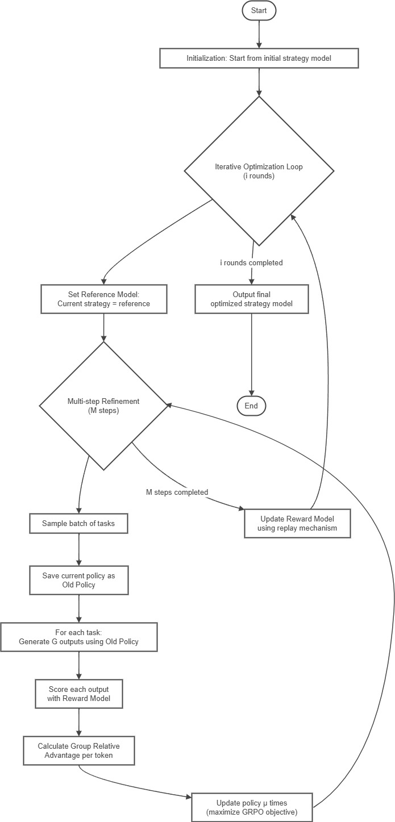

(Figure 6: GRPO)

Application scenario outlook

After discussing the core principles and optimization strategies of DeepSeek, we will continue to explore the practical application scenarios of DeepSeek.

I will focus on integrating DeepSeek into **the local cultural and tourism industry**.

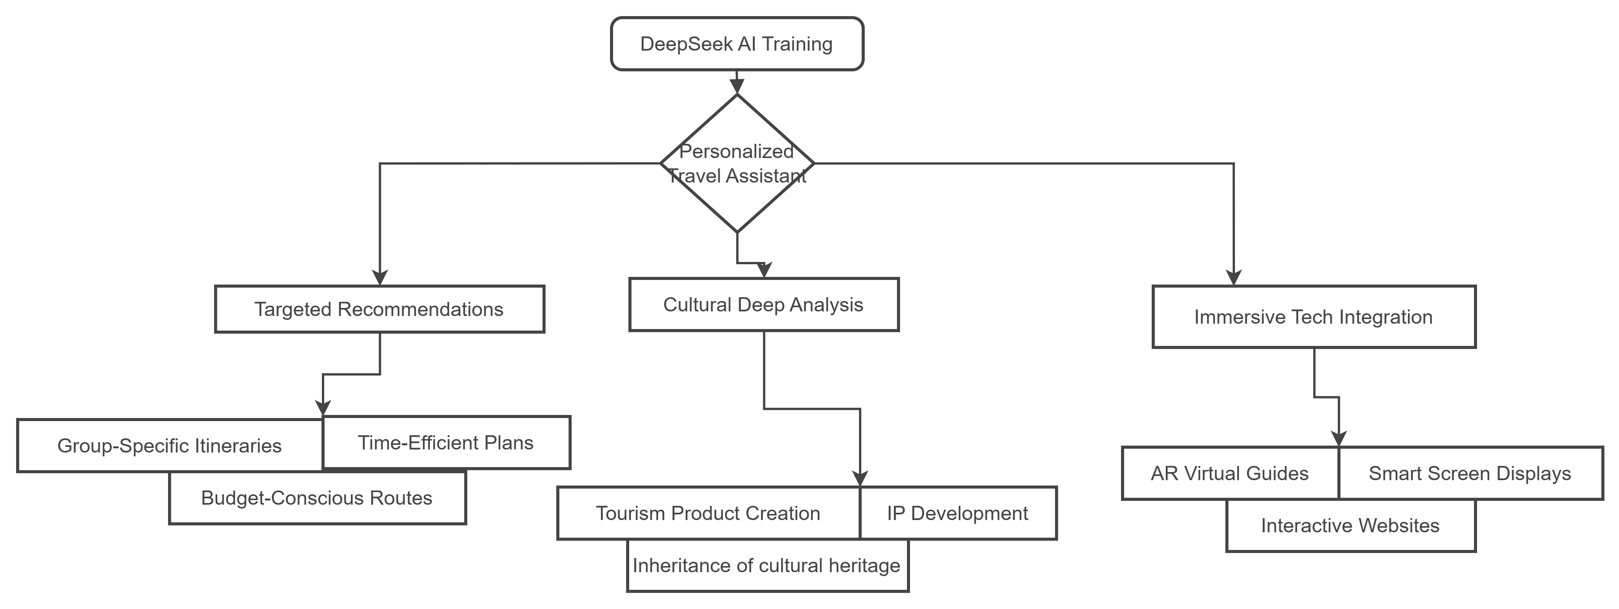

(Figure 7: Application prospects)

When we want to travel to a place and search for travel guides online, most of the time we will find that the guides on the Internet are all the same, and it is very difficult to find a guide that suits our own consumption level and travel habits. However, if we can cooperate with the managers of major local scenic spots and open up the tour routes and data of our own scenic spots to DeepSeek for relevant training, then the trained DeepSeek can become **a tour guide** who is very familiar with the local cultural and tourism landmarks, and thus be able to provide targeted travel suggestions for tourists. Meanwhile, during the process of tourists communicating with DeepSeek, data of different users can also be collected, enabling DeepSeek to better understand the habits of tourists. ( For instance, trained AI can provide a travel route that meets tourists' needs by understanding information such as the number of people traveling, consumption budget, and travel time)

In addition to using DeepSeek to make **personalized recommendations** for travel guides, we can also **combine DeepSeek with technologies like virtual humans, AR** and other technologies, and apply them to the official websites of scenic spots or the smart large screens deployed in the scenic spots, so as to quickly respond to the personalized needs of tourists and create **immersive interactive experiences** for them.

In the in-depth exploration of the cultural connotations of local scenic spots, DeepSeek can also play its role in deep understanding. Based on DeepSeek's in-depth exploration of the cultural background and image characteristics of the IP in scenic spots, we can form various **cultural and tourism consumer goods**.

To train such a tour guide assistant and integrate it into the systems of various scenic spots, we first require data such as visitor flow statistics, scenic spot consumption records, and user consumption habit information. These data will be used for in-depth analysis of cultural tourism brand images, tourist preference behaviors, and hot events identification within cultural tourism sites. Additionally, local cultural knowledge graphs (including local chronicles, folklore, and biographies) is essential to construct a comprehensive cultural ontology library that encompasses historical events, character relationships, and architectural styles. This lays the groundwork for adopting **Retrieval-Augmented Generation (RAG)** technology. Furthermore, the integration of technologies such as digital humans and AR with models like DeepSeek plays a critical role in determining whether the digital human representation of a scenic area can become a landmark feature.

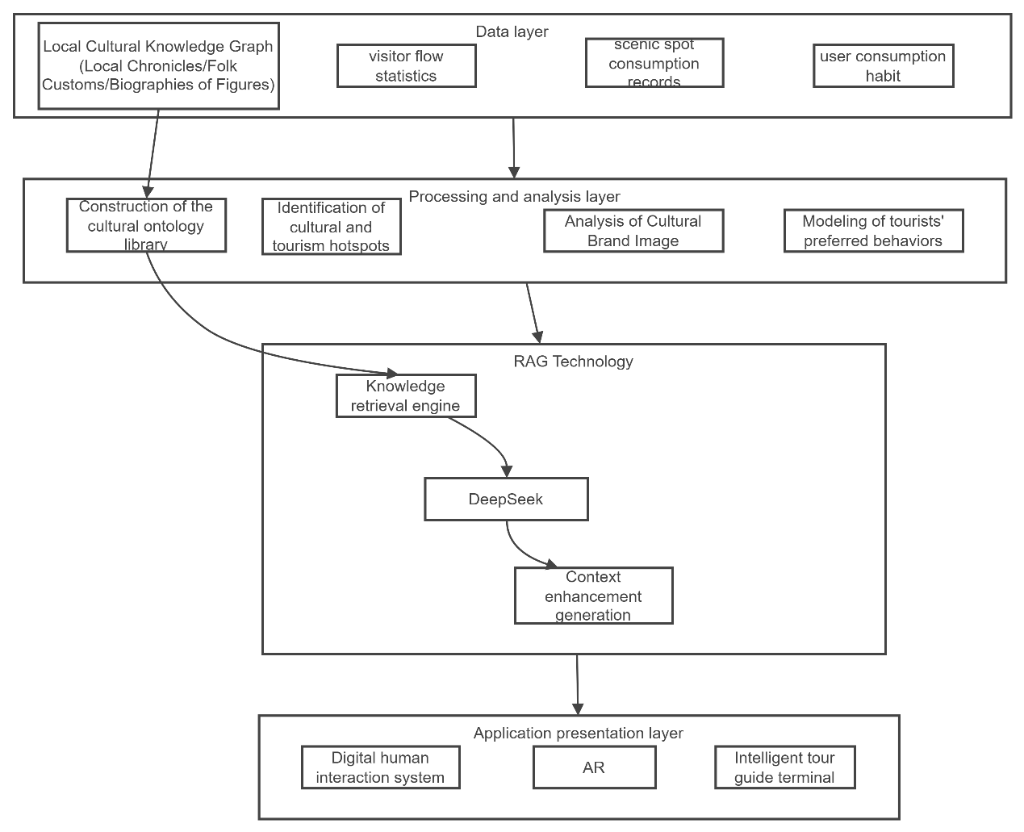

(Figure 8: underlying technical ideas)

If such technology were to be fully realized, one could envision the following scenario: Prior to our trip, the DeepSeek travel assistant would generate a four-day itinerary for three individuals traveling to Beijing. Upon arriving in Beijing and visiting the Old Summer Palace, the digital assistant on our mobile device would track our movements in real time, identifying our current location and providing detailed historical context about the site.

# References

[1] Mnih, V., Kavukcuoglu, K., Silver, D., Graves, A., Antonoglou, I., Wierstra, D., & Riedmiller, M. (2013). Playing atari with deep reinforcement learning. *arXiv preprint arXiv:1312.5602*.

[2] Simonds, T., Lopez, K., Yoshiyama, A., & Garmier, D. (2025). Self Rewarding Self Improving. *arXiv preprint arXiv:2505.08827*.

[3] Liu, A., Feng, B., Xue, B., Wang, B., Wu, B., Lu, C., ... & Piao, Y. (2024). Deepseek-v3 technical report. *arXiv preprint arXiv:2412.19437*.

[4] Guo, D., Yang, D., Zhang, H., Song, J., Zhang, R., Xu, R., ... & He, Y. (2025). Deepseek-r1: Incentivizing reasoning capability in llms via reinforcement learning. *arXiv preprint arXiv:2501.12948*.

[5] Bi, X., Chen, D., Chen, G., Chen, S., Dai, D., Deng, C., ... & Zou, Y. (2024). Deepseek llm: Scaling open-source language models with longtermism. *arXiv preprint arXiv:2401.02954*.